MUHAMMMAD HAMZA ANWAR : 1423039

MAHNOOR AJAZ :1425983

MUHAMMAD ABDULLAH : 1427022

FACULTY

MAM FAREEHA JABEEN

SHREK juice

Famous for variety of juices

# **SHREK JUICE**

INDEX

#### Acknowledgement

#### Project Analysis

#### Requirement Analysis

#### Requirement Gathering

#### Requirement Specification

#### Technologies Used

#### HTML5

#### CSS3

#### JavaScript

#### Bootstrap

#### jquery

#### JSON

#### Solutions to Functional Requirements

#### Details for Customers Only

#### Filtration

ACKNOWLEDGMENT:-

Acknowledgment is not a more formality but a genuine opportunity to thank all those people, whose active support made this project possible. We are thankful to Almighty Allah with his grace. The project that we are successfully presenting on “The SHREK JUICE CENTER Website”. This project has been developed with the help of HTML5 / CSS3 / JS / BOOTSTRAP / JQUERY/JSON. We would like to acknowledge all those who have given moral support and helped us to make this project a success. We wish to express our gratitude to **Miss FARIHA JABEEN** for his valued guidance and support for the completion of this project.

And finally, we would like to offer many thanks to her for his valuable suggestions and constructive feedback.

Project Analysis:-

Requirement Analysis:

Requirements analysis process is an important stage in the system development. It determines the functions of the whole system integrity and stability. Software Requirements analysis is an ongoing process of understanding and progressive refinement.

Requirement Gathering:

The purpose of this project is to create a website where the client can, with satisfaction, buy different types of juices.

***shrekjuice.com*** needs to be constructed considering following requirements:

Shrek-juice is a website of shrek juice center which is big juice center famous for variety of juices it provides. They also provide catering services for various events like wedding , shows and so on with include of new type of juices and also thought of changing lookalike of the website the owner wish to renovate the look and feel of website which should should be more helpful and more catchy for the business perspective.

**Requirement Specification:**

The website is to be based on following requirements

1. The home page should be created making use of section with suitable logo.
2. Few tips can be included in the blank space area of the webpage.
3. The menu must included in the website.
4. Link such as
   1. Product and menu
   2. Fruit and juices
   3. Vegetables juices
   4. Smoothies
   5. Protein shakes
   6. Winter menu
   7. Chocolate juices
   8. Mock tails
5. Store
6. franchising
7. catering
8. contact us
9. feedback
10. About us.

**Standards plan:**

Every code block must have comments.

The logic of the program needs to be explained. Proper documentation should be maintained.

Complete Project Report along with synopsis, code and documentation should be prepared.

Technologies Used:-

**HTML5:**

Hypertext Markup Language revision 5 (HTML5) is a markup language for the structure and presentation of World Wide Web contents. HTML5 supports the traditional HTML and XHTML style syntax and other new features in its markup, New APIs, XHTML and Error handling.

**CSS3:**

Cascading Style Sheets Level 3 (CSS3) is an iteration of the CSS standard used in styling and formatting Web pages. CSS3 incorporates the CSS2 standard with some changes.  
CSS3 makes changes to how some visual elements are implemented and rendered by the browser. However, it is not a single unwieldy specification, unlike CSS2. CSS3 Is separated into separate modules to facilitate development. This means that the specification comes out in   
chunks, with more stable modules than others. Some would be ready for recommendation, while others would be marked as under development drafts, the most recent of which were published as early as June 1999. Some of the major modules of CSS3 are:

#### Image values and replaced content

#### Text effects

#### Selectors

#### Backgrounds and borders

#### Animations

#### User interface (UI)

#### Multiple column layout

**JavaScript:**

HTML pages are fine for displaying static content, e.g. a simple­­ image or text. However, most pages nowadays are rarely static. Many of today’s pages have menus, forms, slideshows and even images that provide user interaction. JavaScript is the language employed by web developers to provide such interaction. Since JavaScript works with HTML pages, a developer needs to know HTML to harness this scripting language’s full potential. While there are other languages that can be used for scripting on the Web, in practice it is essentially all JavaScript.

**BOOTSTRAP:**

Bootstrap makes responsive web design a reality. It makes it possible for a web page or app to detect the visitor's screen size and orientation and automatically adapt the display accordingly.

**JQUERY:**

jQuery is a lightweight, "write less, do more", JavaScript library. The purpose of jQuery is to make it much easier to use JavaScript on your website. jQuery takes a lot of common tasks that require many lines of JavaScript code to accomplish, and wraps them into methods that you can call with a single line of code.

Solutions to FUNCTIONAL REQUIREMENTS

**Our Solutions:**

**Below are our solutions to the requirements specified above in functional requirements.**

1. Details for CUSTOMERS ONLY.

**(1) Solution**

**I provided a specific details through Modal and A Customer can also download PDF’s details.**

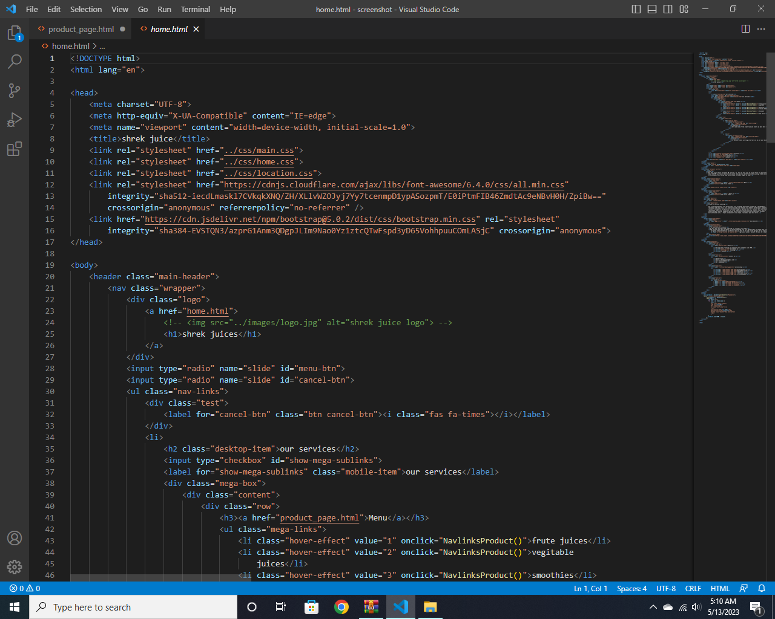

**(2)fILTRATION**

We gave filtration through JS and JQ like when a customer click any product

the information should be categorized according to different type of products

a User wants. For example a customer wants to drink only sugarcane juice then he click on a Link/button/menu



 

